**BULLETIN NOTICE (< 100 words)**

**Shape our future with our new Pastoral Plan for 2024 – 2028**

The Diocese of Parramatta has recently launched our Pastoral Plan for a Synodal Church 2024-2028: *‘Behold, I am with you’*. Our pastoral plan represents the culmination of our Synod journey, where we have come together to listen, discern, and envision a path forward for our diocese over the past 16 months. Together, we can use this plan to revitalise our local community and shape the future of our Diocese. To download a copy of the Diocesan Pastoral Plan, visit [parracatholic.org/synodality](http://parracatholic.org/synodality).

**NEWSLETTER CONTENT**

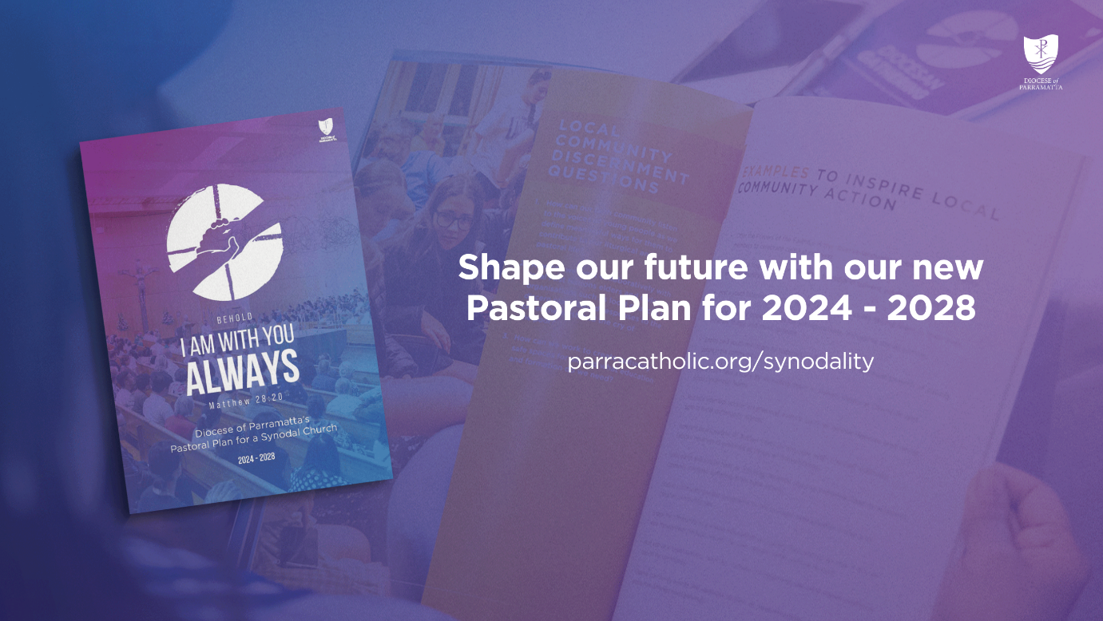

The Diocese of Parramatta is excited to announce the launch of our **Pastoral Plan for a Synodal Church 2024-2028: *‘Behold, I am with you’*.** This plan marks the culmination of our 16-month Synod journey, a time of listening, discernment, and envisioning the future of our Diocese. Now, we have a shared roadmap to revitalise our local communities and guide our mission in the years ahead. To explore and download the Pastoral Plan, [CLICK HERE.](https://parracatholic.org/wp-content/uploads/2024/08/Behold-I-Am-With-You-Always-Pastoral-Plan-for-a-Synodal-Church-2024-2028-WEBv.pdf)

