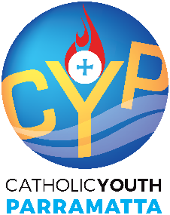

LIFTED Retreat 2025
(Year 10-12 Students)
8 July 2025
Parents/guardians of all participants must complete the following and submit it to the registration desk upon arrival.

I, ___________________________________ give permission for my son/daughter to attend the LIFTED Retreat (Year 10-12 students) on 8 July, 2025.
LIFTED Retreat involves participation prayer, Catholic sacraments, group discussions and team building activities with other young people. I understand the nature and risks of the activities and give permission for my child to participate.

NAME OF PARTICIPANT: ____________________________________________ AGE: _____________

PARISH/SCHOOL/FAITH COMMUNITY: __________________________________________________

SIGNED: _________________________________________________________ DATE: ____________

EMERGENCY CONTACT NUMBER: _____________________________________

